A Transraciolinguistic Approach for Literacy Classrooms

Patriann Smith, PhD

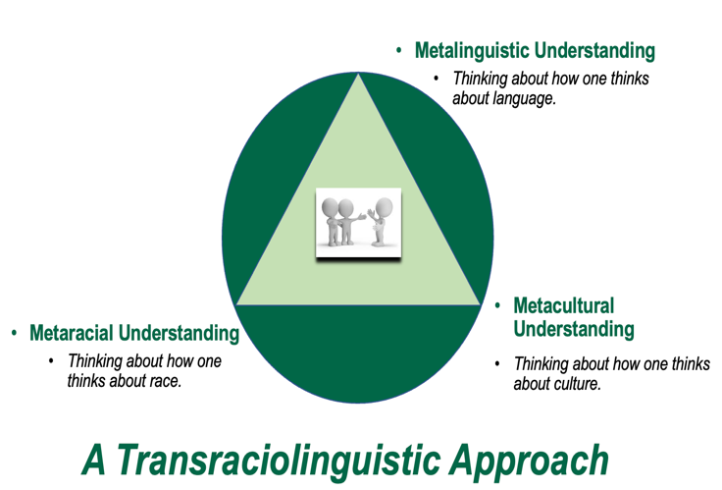
A Transraciolinguistic Approach for Racialized Students: Level 1

- Acknowledge the influence of the White Gaze and how it intersects with Migration and Language use to Influence Literacy Curriculum

Smith, P. (Accepted, 2021). Migrating while multilingual and Black: Literate experiences of invisible youth. In E. Bauer (Ed.), Enhancing bilingual education: A transdisciplinary lens for improving learning in bilingual contexts. New York, NY: Routledge.

- Phonics: Proper pronunciation, proper accent, accent reduction
(i.e., White listening subject + … Migration + Language)
- Spelling: Correct spelling (White gaze + … Migration + Language)
- Writing: Writing well (White gaze + … Migration + Language)
- Vocabulary: Correct vocabulary (White gaze + … Migration + Language)
  - Goal of Reading and Literacy: Meaning-Making/Comprehension

A Transraciolinguistic Approach for Racialized Students: Level 2

- Disrupt and Dismantle Eurocentric Literacy Curriculum

Smith, P. (In review). A transraciolinguistic approach for literacy classrooms. The Reading Teacher.

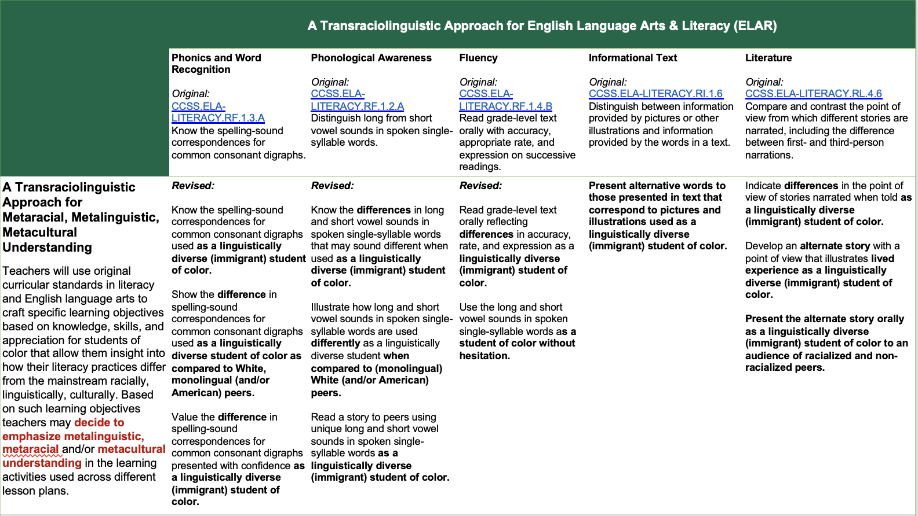
A Transraciolinguistic Approach for Racialized Students: Level 3

- Create Storylines with Racialized Youth

Smith, P. (2019). (Re)Positioning in the Englishes and (English) literacies of a Black immigrant youth: Towards a ‘transraciolinguistic’ approach. Theory into Practice, 58(3), 292-303. DOI:10.1080/00405841.2019.1599227.

Rationale

- Black immigrant populations often grapple with understanding how they are positioned by Black & other racialized peers as well as White peers.
- There is no reason why literacy curriculum should fail to prepare racialized (Black) (im)migrant/transnational middle/high-school students to identify and leverage their assets with these diverse peers.
- English literacy curriculum worldwide can no longer obscure this disconnect designed by white supremacy. Institutions must design literacy learning to address prevailing fallacies held by Blacks about each other.
- The next figure, “English Language Arts & Literacy (ELAR) Instructional Module,” presents a visual depiction of how teachers can design modules that tap into Black immigrant & Black American students’ transraciolinguistic assets via metalinguistic, metacultural, metaracial understanding.

Steps for Fostering a Transraciolinguistic Approach with Racialized (Black) Youth

- Step One: Determine the "speech act" (i.e., oral interview, narrative, role play, multimodal product, etc.) through which the student will provide information about his or her academic and literate trajectory regarding intersections between (English) language, race, and other elements of culture broadly speaking.
  - Example: Jaeda’s Oral Interview is the “Speech Act” (see Appendix A)

- Step Two: Identify, with the student, how they position their language, race, and culture in general as well as how significant others position these elements when they are engaged in literate encounters. Identify the student's reaction to being positioned in this way. Identify how the student responds when they perceive that they are positively and negatively positioned.
  - Example: Jaeda creates a “Storyline” with Me

Views herself as Learner of English – Believes mother expects her to learn to speak English better

Views mother as Non-proficient in English –Mother responds by wanting to learn to speak English better

Begins to view herself as Flexible with English repertoires – Decides to preserve all her Englishes

Begins to view Mother as Proficient with Language – Mother responds by passing on proficiency in English (and other) languages

Speech Act – Oral Interview Conversations between Jaeda and her mother.

Storyline – Literate vs. Illiterate
Standardized English (or standardized language) is the goal. Those who don’t speak it are illiterate. If Jaeda wants to demonstrate she is literate, she needs to speak standardized English and other standardized language forms.

Figure 1: Storyline: Jaeda’s Positioning in Interactions with her Mother

- Step Three: Discuss with the student the elements that they use to overcome the negative positioning reflected in their "story-line". Work with the student to identify elements that they already use to develop a sense of agency in response to this positioning as well as other elements that they may have overlooked that can be useful based on their storyline.
- Step Four: Discuss with the student the elements that they use to overcome the negative positioning reflected in their "story-line". Work with the student to identify elements that they already use to develop a sense of agency in response to this positioning as well as other elements that they may have overlooked that can be useful based on their storyline.
- Step Four: Revisit, with the student, the "story-lines" developed, after time has elapsed to enable them to identify how his or her sense of agency has evolved based on the agentive practices used.
A Transraciolinguistic Approach for Racialized Students: Level 4

- Revamp Instructional Modules to Connect Racialized Youth

Smith, P. (2021). Five steps to address anti-Blackness: Black immigrant literacies. International Literacy Research Association Literacy Now Blog. Retrieved from https://www.literacyworldwide.org/blog/literacy-now/2021/03/17/five-steps-to-address-anti-blackness-black-immigrant-literacies

- There is continued disconnect within the Black population worldwide.
- There is no reason why literacy curriculum should fail to prepare racialized Black (im)migrant/transnational middle and high-school students to interact with Black peers of different backgrounds.
- English literacy curriculum worldwide can no longer obscure this disconnect designed by white supremacy. Institutions must design literacy learning to address prevailing fallacies held by Blacks about each other.
- The next figure, “English Language Arts & Literacy (ELAR) Instructional Module,” presents a visual depiction of how teachers can design modules that tap into Black immigrant & Black American students’ assets via metalinguistic, metacultural, metaracial understanding.

A Transraciolinguistic Approach for Mainstream Classrooms: Level 5

- Leverage a Transraciolinguistic Approach for All Students

  - A transraciolinguistic approach would not achieve its goals in literacy teaching and learning if it failed to move beyond the racialized students who are often on the receiving end and if it does not address organizations such as schools that continue to perpetuate raciolinguistic ideologies.
  - Teachers of literacy who are responsible for the instruction of non-racialized populations (i.e., white students) are capable of also leveraging a transraciolinguistic approach, enabling students perceived as monolingual, monocultural and monoracial, to better relate to racialized peers using metalinguistic, metacultural and metaracial understanding.
  - The instructional/lesson plan presented next is used to illustrate (see Appendix B).

Recommended Readings

- Patriann Smith: Finding (radical) hope in literacy: Pedagogical literacy insights from culturally and linguistically diverse students. Literacy Practice and Research, 43(3), 5-15.
- Patriann Smith: (Re)Positioning in the Englishes and (English) literacies of a Black immigrant youth: Towards a ‘transraciolinguistic’ approach. Theory into Practice, 58(3), 292-303.
- Patriann Smith: Silencing invisibility: Towards a framework for Black immigrant literacies. Teachers College Record, 122(13).
- Patriann Smith: “How does a Black person speak English?”: Beyond American language norms. American Educational Research Journal, 57(1), 106-147. DOI: https://doi.org/10.3102/0002831219850760
- Patriann Smith, Jason Lee, & Rong Chang (2020, Advance online publication): Characterizing competing tensions in Black immigrant literacies: Beyond partial representations of success. Reading Research Quarterly. DOI:10.1002/rrq.375
- Patriann Smith: The case for translanguaging in Black immigrant literacies. Literacy Research: Theory Method, and Practice, 69(1), 192-210. DOI: https://doi.org/10.1177/2381336920937264
- Patriann Smith: Five steps to address anti-Blackness: Black immigrant literacies. International Literacy Research Association Literacy Now Blog. Retrieved from https://www.literacyworldwide.org/blog/literacy-now/2021/03/17/five-steps-to-address-anti-blackness-black-immigrant-literacies
- Patriann Smith: Translanguaging in the literacies of youth migrating to the U.S. and racialized as Black. American Educational Research Association Bilingual Education Research Special Interest Group Newsletter, Spring Edition. [Invited] Retrieved from https://www.academia.edu/45456174/Beyond_Anti_Blackness_in_Bilingual_Education_Looking_through_the_Lens_of_the_Black_Immigrant_Subject_American_Educational_Research_Association_BER_SIG_Newsletter_
- Arlette Willis, Patriann Smith, Jung Kim, & Betina Hsieh (Commissioned, Press Release, 2021): Racial justice in literacy research. Literacy Research Association. Retrieved from https://www.prnewswire.com/news-releases/racial-justice-research-report-released-by-the-literacy-research-association-301256285.html
- Geneva Smitherman: Raciolinguistics, “Mis-Education,” and Language Arts Teaching in the 21st Century
- Kate Seltzer: Translating Theory to Practice: Exploring Teachers' Raciolinguistic Literacies in Secondary English Classrooms
- Maneka Brooks: “She Doesn’t Have the Basic Understanding of a Language”: Using Spelling Research to Challenge Deficit Conceptualizations of Adolescent Bilinguals
- Nelson Flores and Jonathan Rosa: Undoing appropriateness: Raciolinguistic ideologies and language diversity in education. Harvard Educational Review, 85, 149-171.
- Jonathan Rosa: Standardization, racialization, languagelessness: Raciolinguistic ideologies across communicative contexts. Journal of Linguistic Anthropology, 26, 162-183.
- Sophia Bahena: Differences as Deficiencies – The Persistence of the 30 Million Word Gap
- Ofelia Garcia: Interrogating the Language Gap of Young Bilingual and Bidialectal Students
Recommeded Media
- Kelly Wight: All Things Linguistic
- Jonathan Rosa on Why We Need a Raciolinguistic Perspective
- Adam Schwarts: Language, Mockery and Racism: The Case of Mock Spanish
- DUOcon with Nicole Holliday
- DUOcon with Anne Charity Hudley
- Hearing Racialized Language in Josh Inocéncio’s Purple Eyes (Ojos Violetas)
- Speak English or Else You’ll Be Put on Dish Duty!
- Hearing Race: Hearing Race: Can Language Use Lead to Racism?
- The Reason You Discriminate Against Foreign Accents Starts with what they do to Your Brain
- Hearing Racialized Language in Josh Inocéncio’s Purple Eyes (Ojos Violetas)
Follow on Twitter
- Vijay Ramjattan | Jonathan Rosa | Anne Charity-Hudley | Nicole Holliday | Maneka Brooks | April Baker-Bell | Lakeya Omogun | Nelson Flores | Aris Clemons | Uju Anya | Patriann Smith

Appendix A
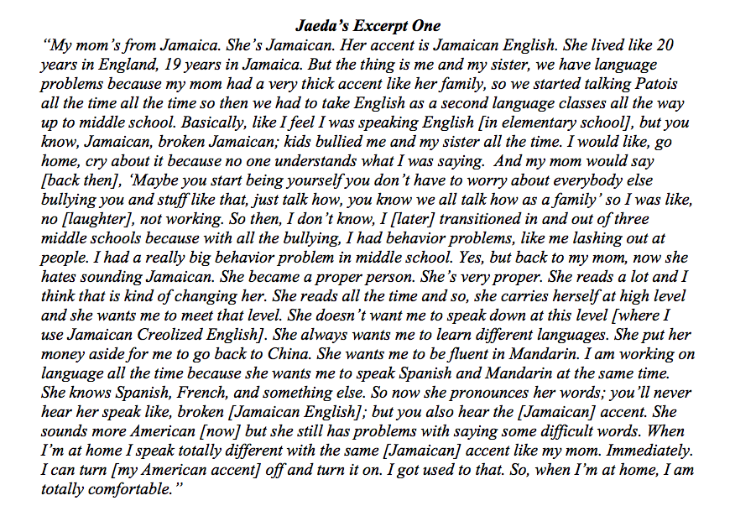

Appendix B

